Task 1. Passengers must be at least 10 years old
A constraint chk_passenger_min_age was added to the passengers table. It checks that the date of birth (date_of_birth) is not later than 10 years before the current date. If a passenger younger than 10 is inserted, the database rejects the record with a violates check constraint error.
Task 2. Ticket price limit
A constraint chk_booking_price was added to the booking table. The ticket_price value must be at least 0 and at most 50000 tenge. Negative prices and prices above 50000 are not accepted.
Task 3. Luggage weight between 1 and 23 kg
A constraint chk_baggage_weight with the condition weight_in_kg BETWEEN 1 AND 23 was added to the baggage table. The range boundaries are inclusive. Luggage lighter than 1 kg or heavier than 23 kg is rejected.
Task 4. Airport name length
A constraint chk_airport_name_len was added to the airport table. The LENGTH function counts the characters in airport_name, and the result must be at least 10. Because the table already contained short names, the constraint was added with the NOT VALID option, so it checks only new and updated records and does not affect existing data.
Task 5. UNIQUE constraints in every table
UNIQUE prevents duplicate values in a column or a set of columns. The following constraints were added:
- passengers (passport_number): two passengers cannot have the same passport number.
- airport (airport_name): airport names cannot repeat.
- booking (passenger_id, flight_id): one passenger cannot book the same flight twice.
- baggage (baggage_id, booking_id): the combination of baggage ID and booking ID must be unique.
- flights (airline_id, departing_airport_id, sch_departure_time): one airline cannot have two flights from the same airport at the same time.
When a duplicate is inserted, the database returns the error duplicate key value violates unique constraint.
Task 6. Minimum age depends on gender
A constraint chk_gender_age was added to passengers. For males ('M'), the date of birth must be at least 18 years ago; for females ('F'), at least 19 years ago. The conditions are combined with OR: a row is accepted if the rule for its gender is satisfied.
Task 7. Minimum age depends on country of citizenship
The constraint chk_country_age uses a CASE expression on the country_of_citizenship column:
- Kazakhstan: at least 18 years old.
- France: at least 17 years old.
- All other countries (ELSE): at least 19 years old.
Task 8. ticket_discount column and date-based discount
A new column ticket_discount was added to the booking table. Existing rows were filled using an UPDATE statement. Then the constraint chk_ticket_discount was added: for tickets created on or after 2024-01-01 the discount equals 5% of ticket_price, and for tickets created earlier it equals 10%. If an inserted discount does not match the formula, the record is rejected.
Task 9. Default value for booking status
The command ALTER COLUMN status SET DEFAULT 'Confirmed' set a default value for the status column in booking. A new booking was then inserted without specifying status. The SELECT query shows that the new row automatically received the status Confirmed.
Task 10. Automatic current date
The default value CURRENT_DATE was set for the created_at column in the booking table. A record was then inserted without specifying created_at. The SELECT result shows that the current date was stored automatically.
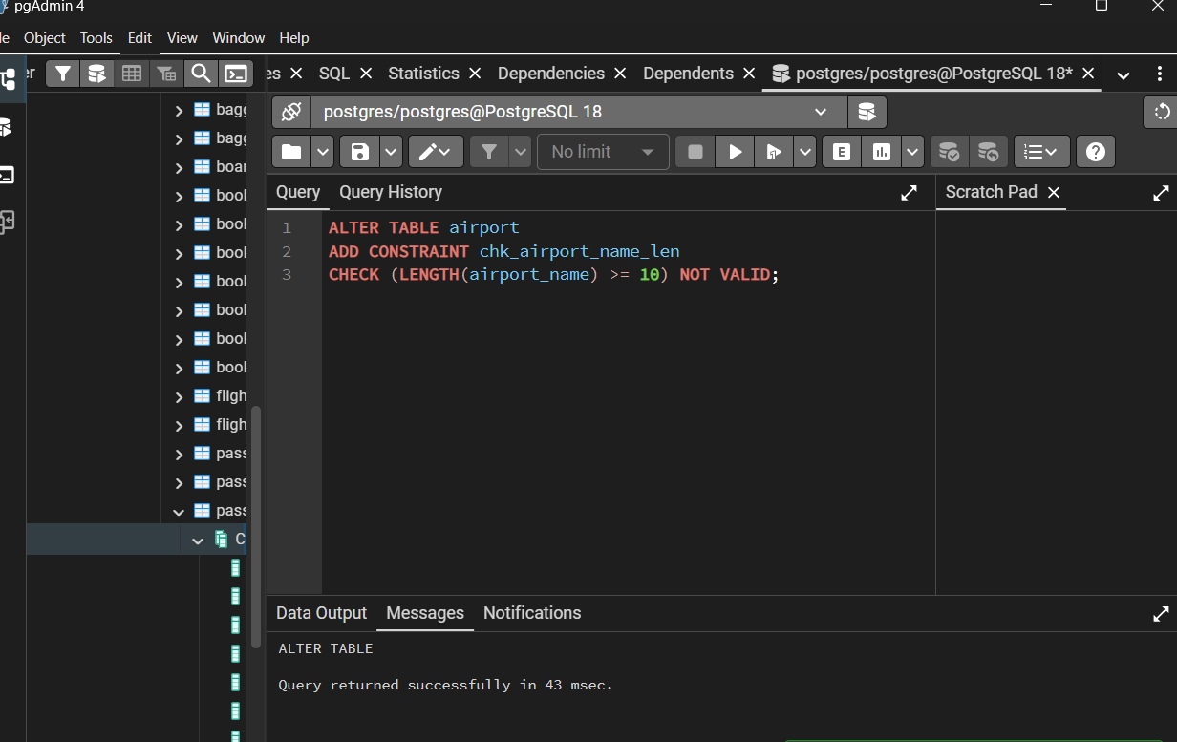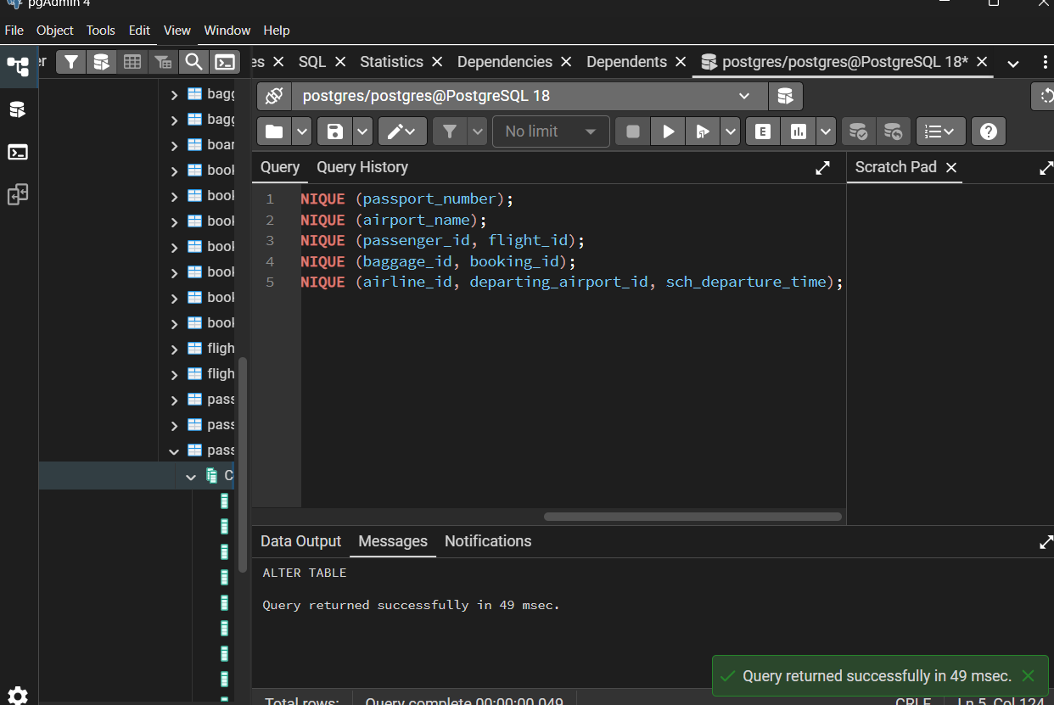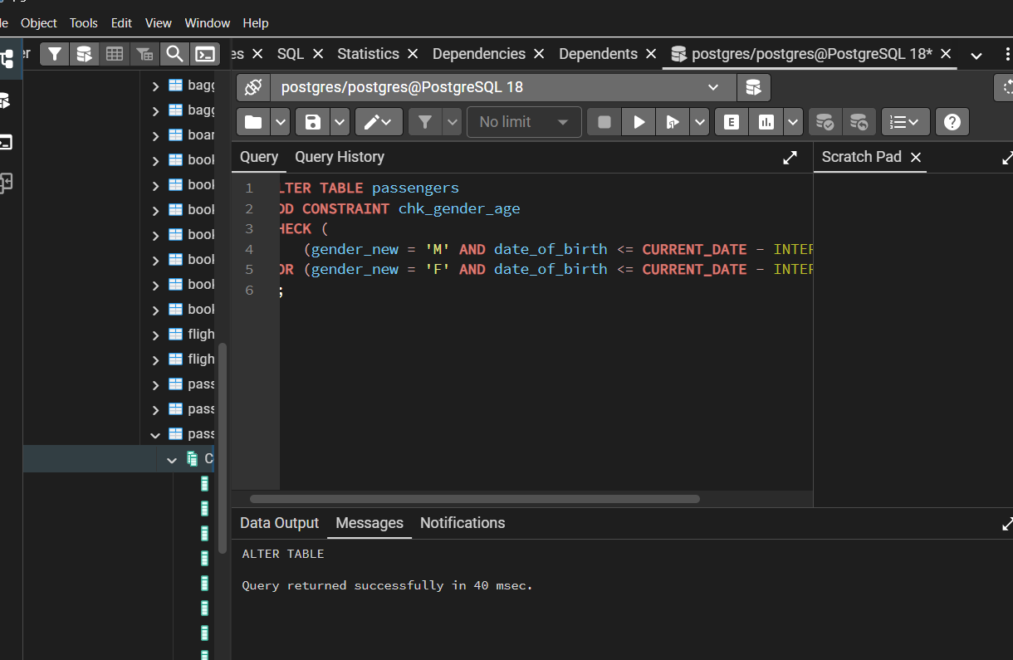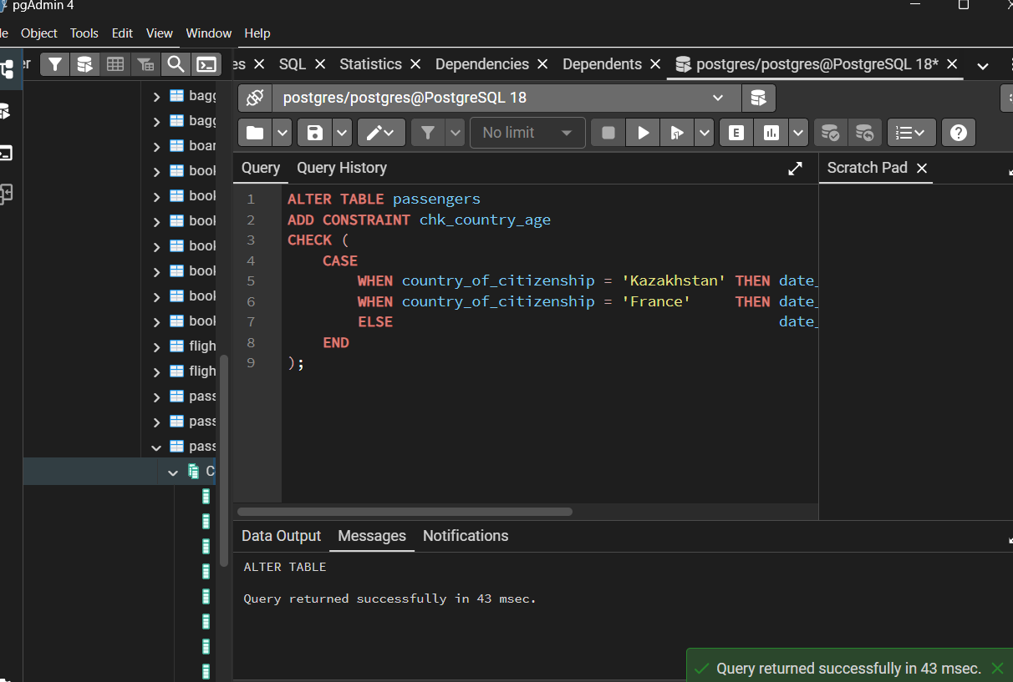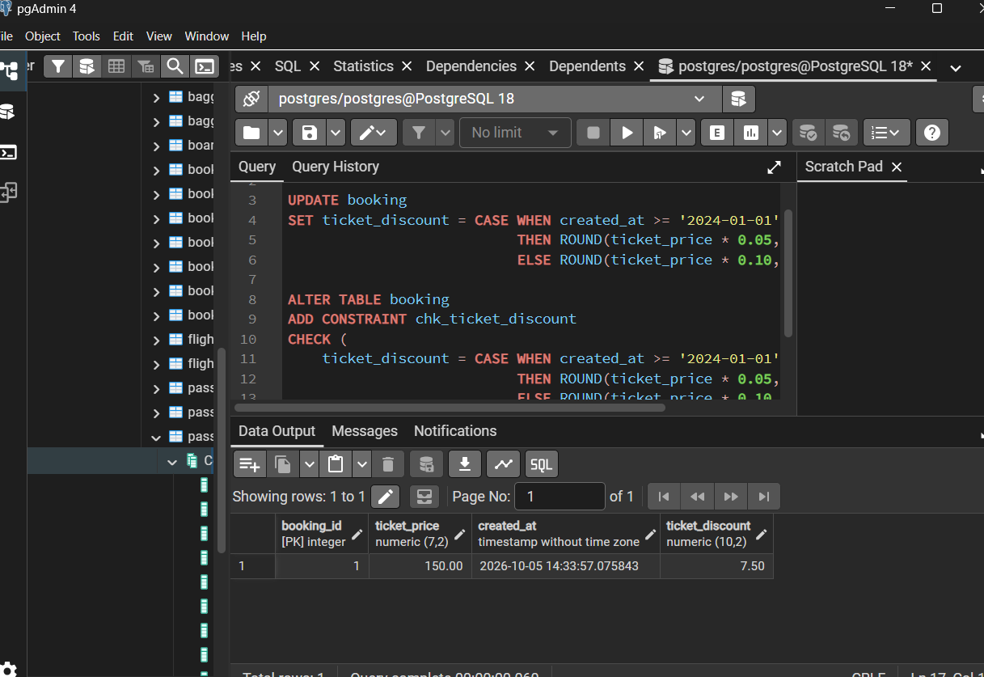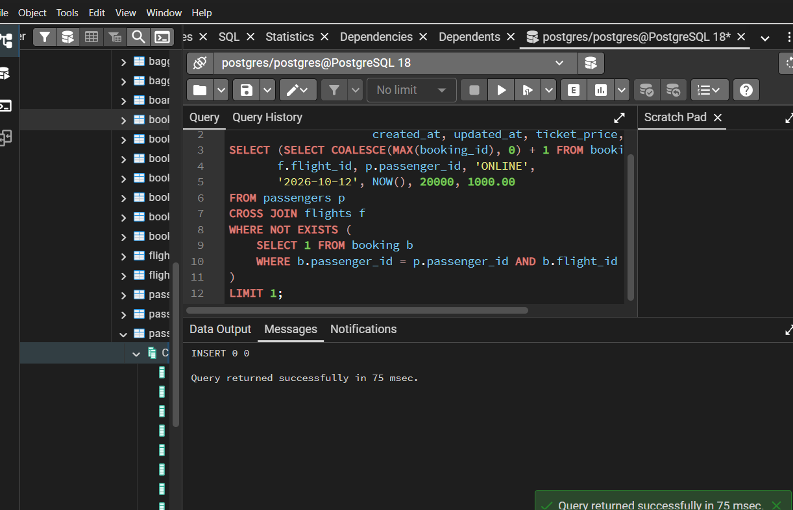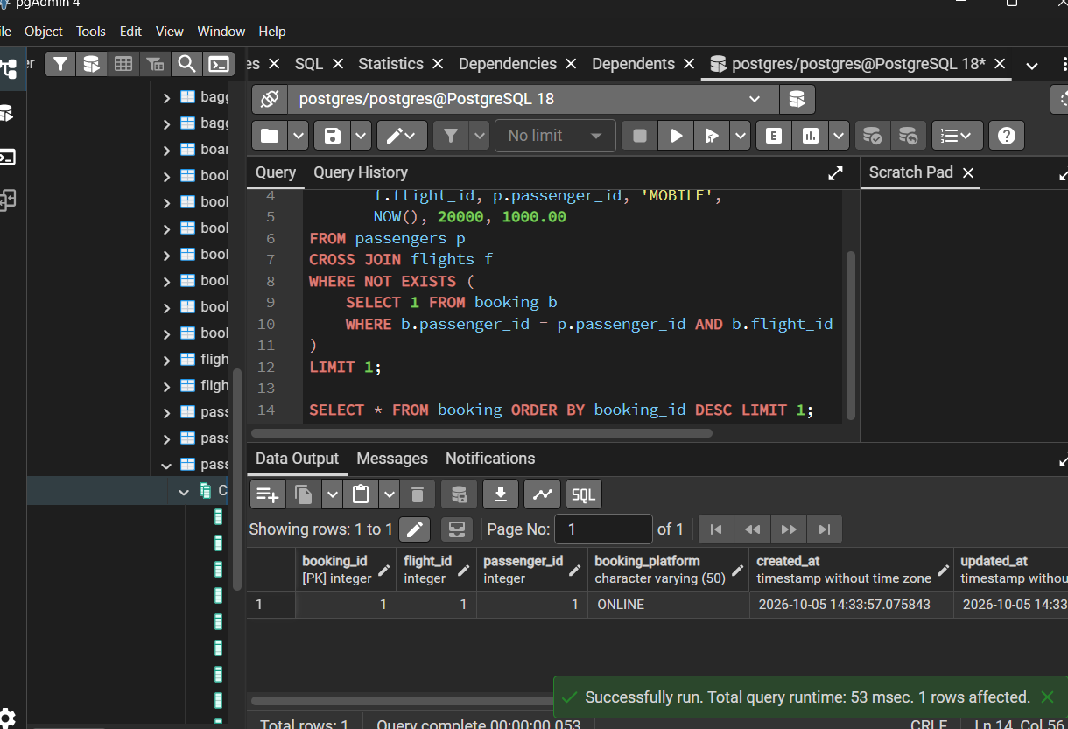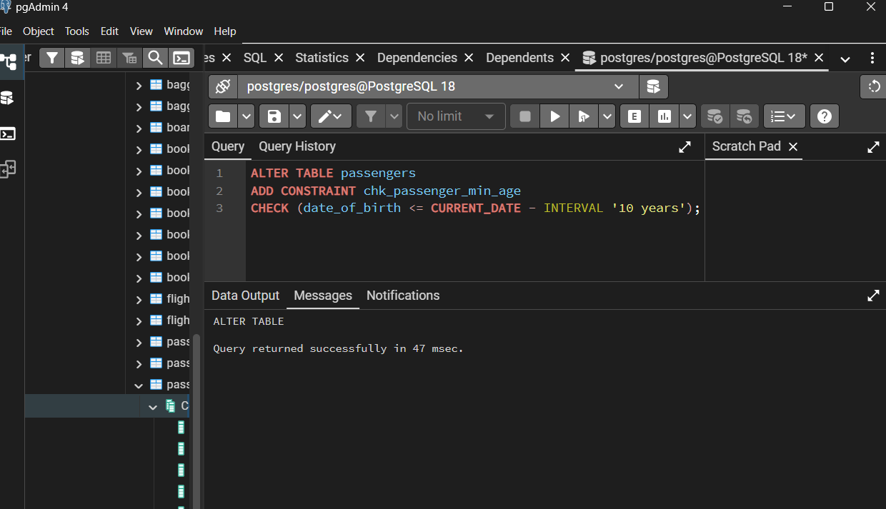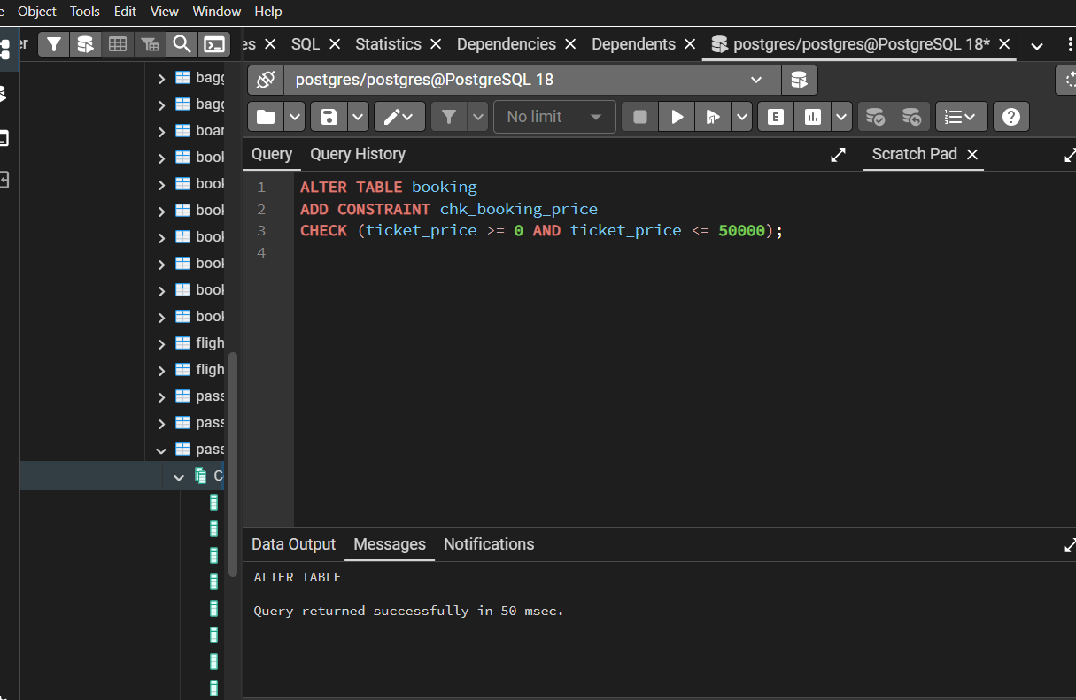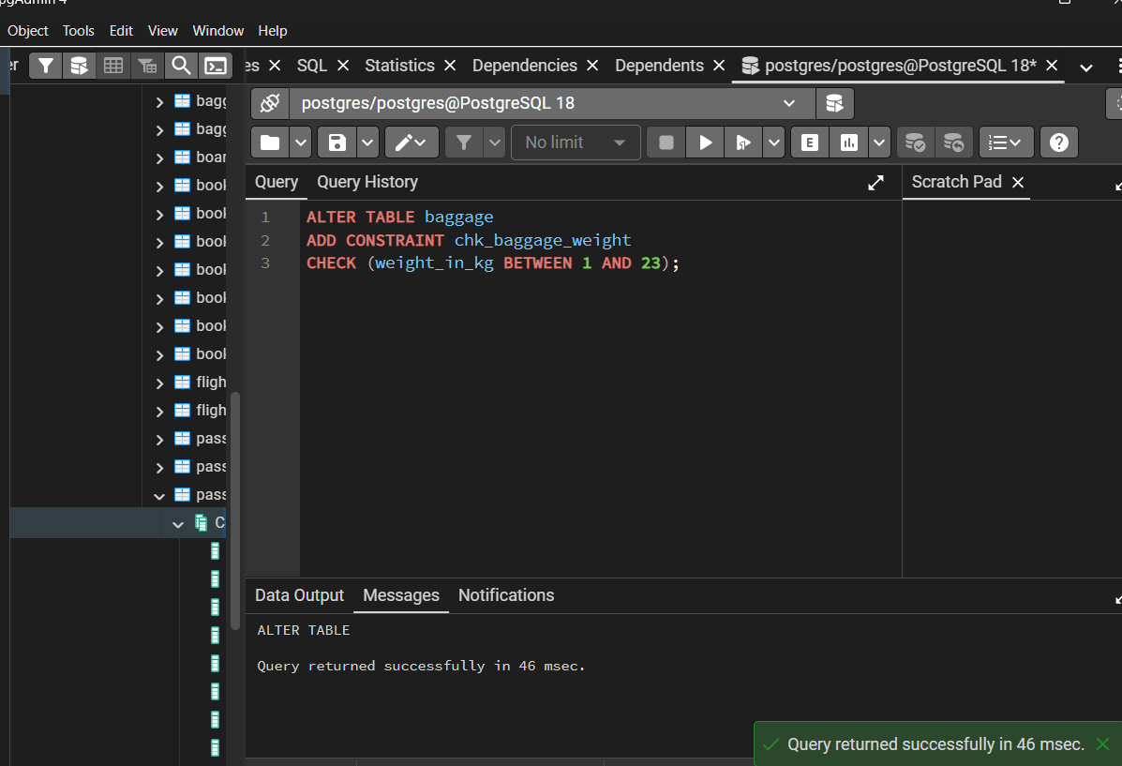
Conclusion (for the end of the report)
In this laboratory work, integrity constraints in PostgreSQL were studied. CHECK was used to implement business rules (age, price, weight, name length, discount). UNIQUE was used to prevent duplicate data. DEFAULT was used to fill columns automatically. Test inserts that violate the rules confirmed that the database rejects invalid data, and the errors SQL state 23514 (CHECK) and 23505 (UNIQUE) occur as expected.

